1.EC2 instance - Docker-server-1:
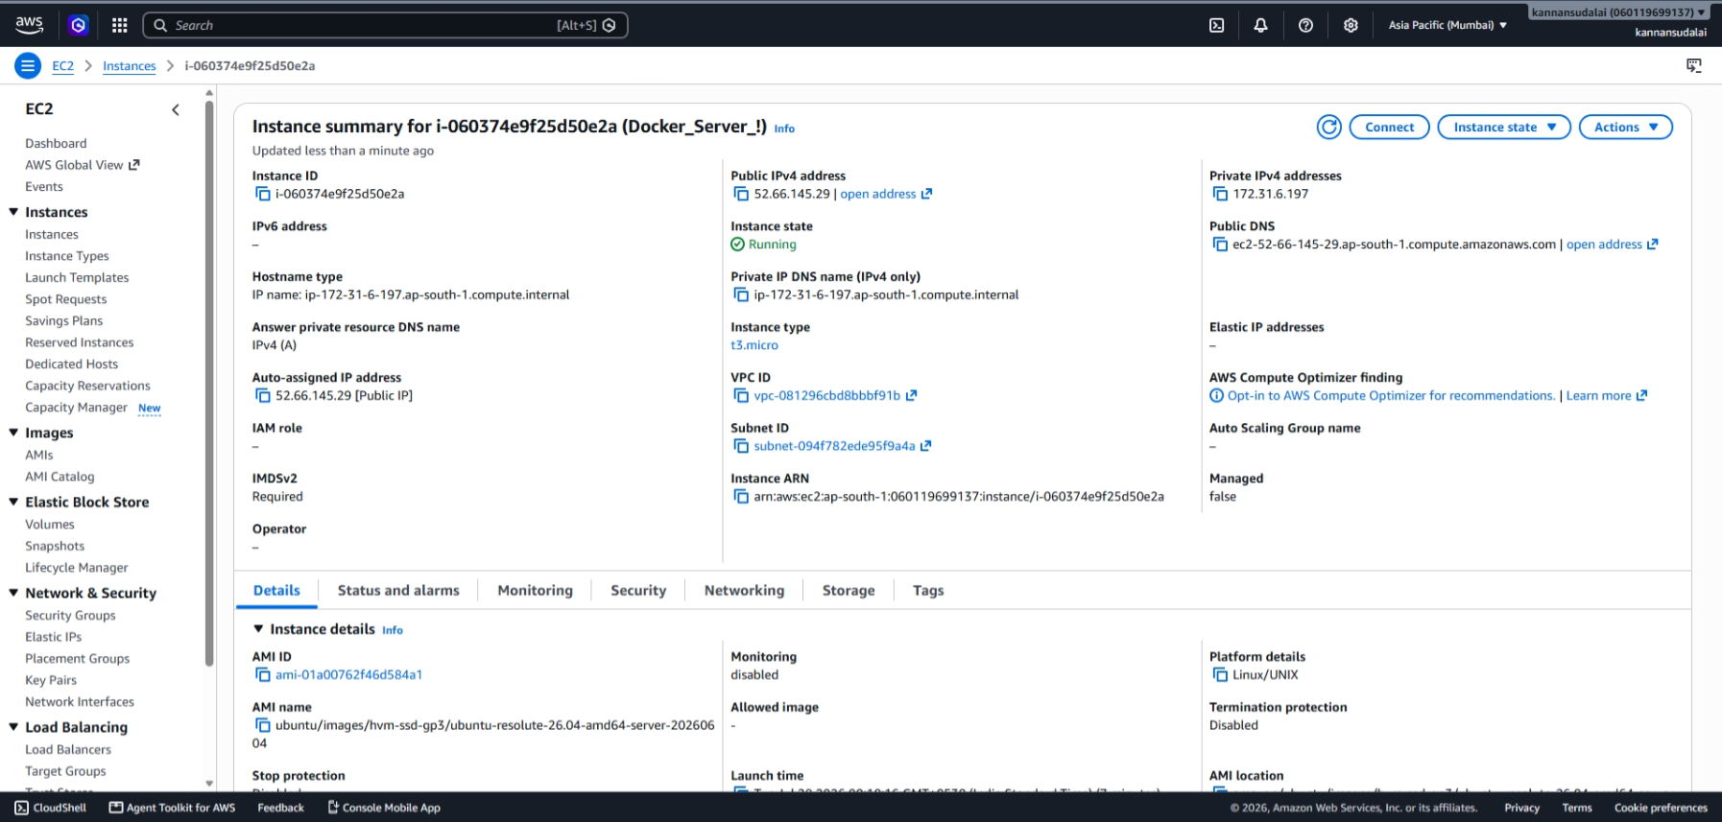

2.Installed Docker and Docker Compose:
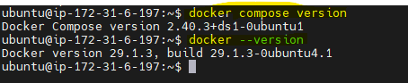

3.Dockerfile: This fetches latest nginx from dockerhub and copies index.html from current directory to the container’s /usr/share/nginx/html/index.html location (This executes when running docker compose build)
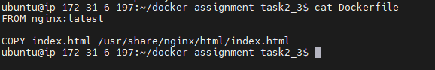

4.Docker compose build nginx:
It reads the Dockerfile and creates a Custom Docker Image.
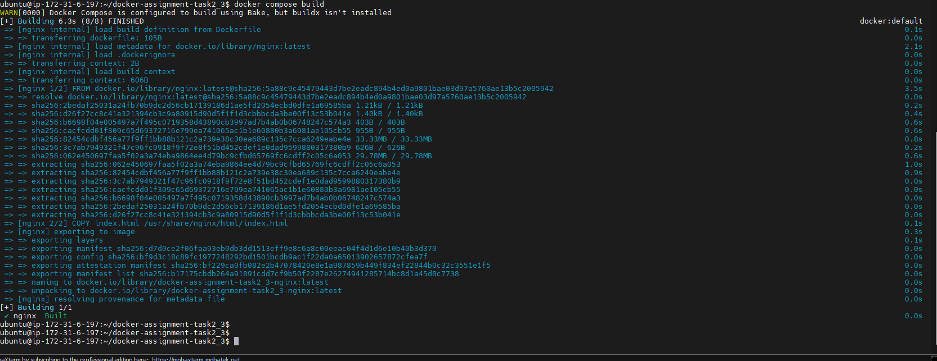
5.Below custom docker image is built using above command:
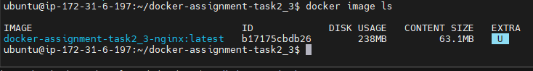
6.Docker compose yaml file:
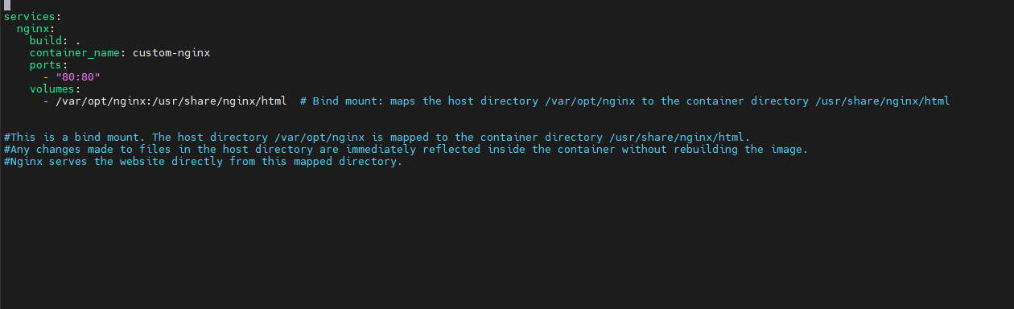

7.Run the container: using “docker compose up -d” command creates the container.
and check container status using docker ps command.
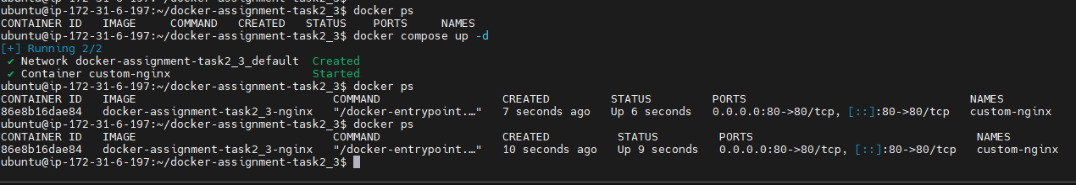

8.Check if the Website is accessible as our container with nginx is currently running now:
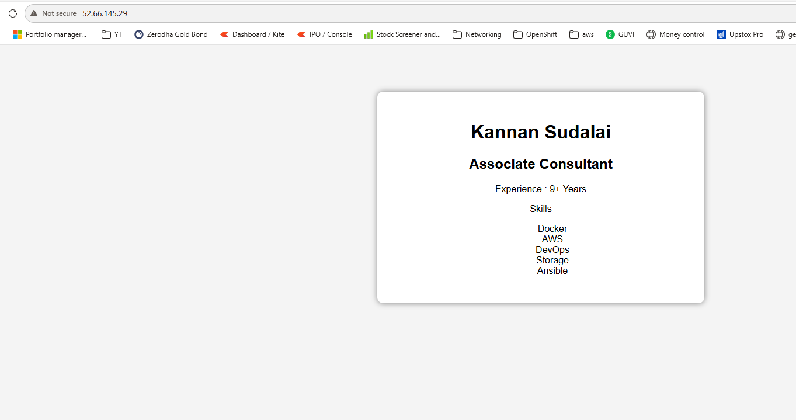
9.As the BIND mount enabled from local directory file to the container directory file, changes done on the local directory index.html file should reflect in the container website.
I have added kubernetese and English and Japanese in the local file which is reflecting in the webpage.
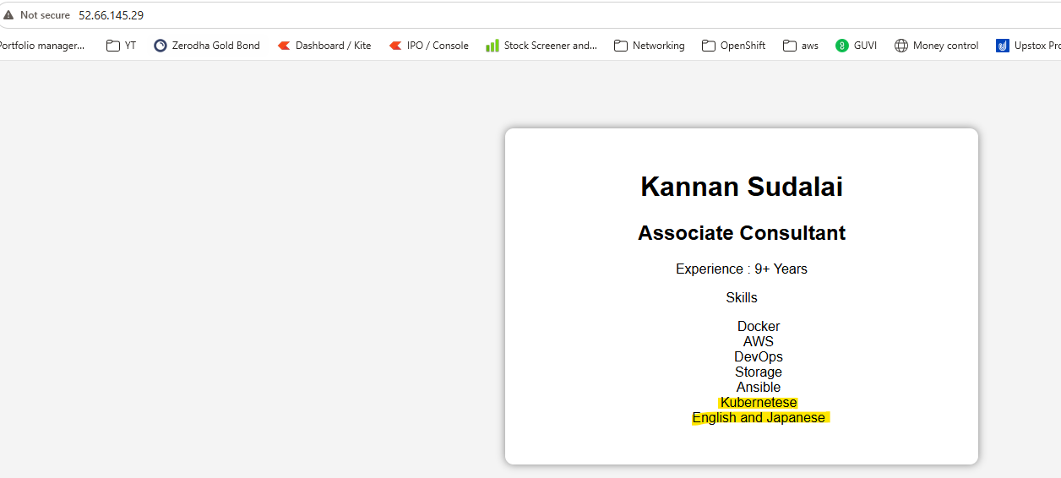
BIND MOUNT requires no rebuild, we can just refresh the browser to see the changes.
10.I have added kubernetese and English and Japanese in the local file which is reflecting in the webpage.
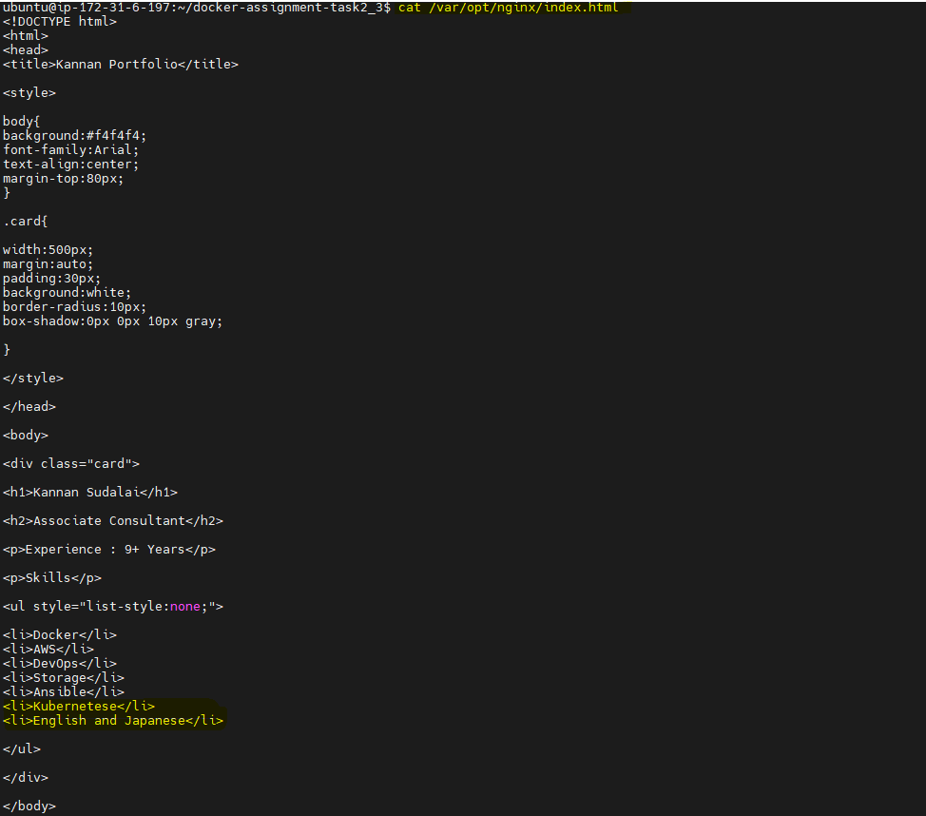

- Stop the container:
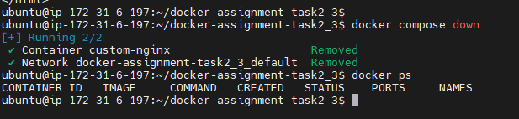

- Login to dockerhub:
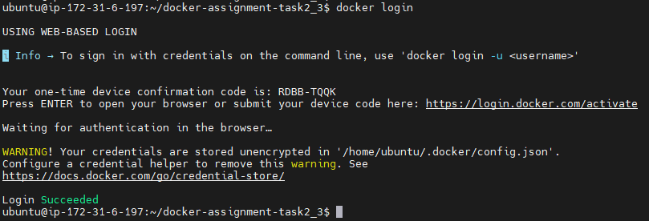

- Docker image pushed to docker hub:
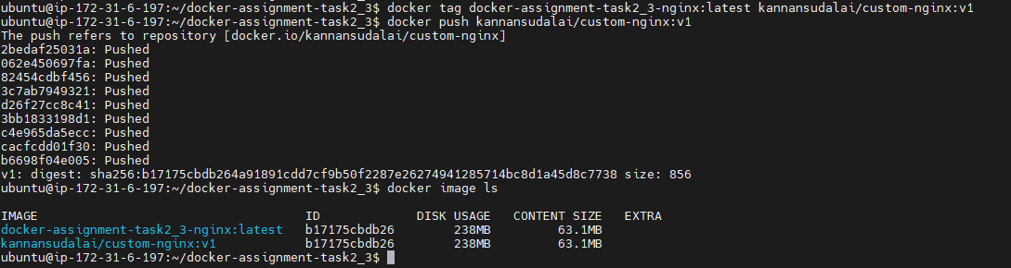

Below confirms the same Imaged id in docker hub so it successfully pushed:
